Geo-based

🌍 What Is Geo-based Load Balancing?
# Source: AI Source: Provided by: [Data Path: Persons Table -> ID Column: 1, Name_En Column: Motasem Essam] -> From: [ChatGPT] on [12/15/2025]
Geo-based load balancing (also called geolocation routing) is a strategy where the load balancer routes a user's request to the closest server based on their geographic location (country, region, or continent).

✅ Simple Definition:
# Source: AI Source: Provided by: [Data Path: Persons Table -> ID Column: 1, Name_En Column: Motasem Essam] -> From: [ChatGPT] on [12/15/2025]
Geo-based load balancing sends users to the server that’s physically nearest to them — to reduce latency and improve performance.

🧠 Real-Life Analogy:
# Source: AI Source: Provided by: [Data Path: Persons Table -> ID Column: 1, Name_En Column: Motasem Essam] -> From: [ChatGPT] on [12/15/2025]
Imagine you’re ordering pizza:
- If you live in Cairo, you get pizza from the nearest Cairo branch
- If you live in Paris, you get it from the Paris branch
It’s faster and more efficient — that’s exactly what geo-based routing does.

🗺️ How It Works
# Source: AI Source: Provided by: [Data Path: Persons Table -> ID Column: 1, Name_En Column: Motasem Essam] -> From: [ChatGPT] on [12/15/2025]
- 🌐 A user makes a request
- 🌍 The load balancer detects the user’s IP location
- 🚦 It routes the request to the nearest server location
For example:
- User from Germany → gets routed to Frankfurt server
- User from Brazil → gets routed to São Paulo server

📈 Benefits of Geo-based Routing
# Source: AI Source: Provided by: [Data Path: Persons Table -> ID Column: 1, Name_En Column: Motasem Essam] -> From: [ChatGPT] on [12/15/2025]
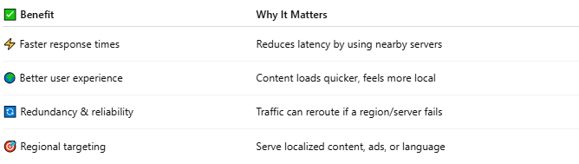

✅ Benefit | Why It Matters
⚡ Faster response times | Reduces latency by using nearby servers
🌍 Better user experience | Content loads quicker, feels more local
🔄 Redundancy & reliability | Traffic can reroute if a region/server fails
🎯 Regional targeting | Serve localized content, ads, or language

🧱 Example Providers That Support Geo-based Load Balancing
# Source: AI Source: Provided by: [Data Path: Persons Table -> ID Column: 1, Name_En Column: Motasem Essam] -> From: [ChatGPT] on [12/15/2025]
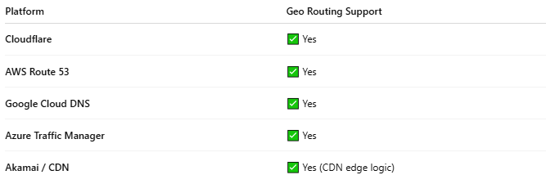

Platform | Geo Routing Support
Cloudflare | ✅ Yes
AWS Route 53 | ✅ Yes
Google Cloud DNS | ✅ Yes
Azure Traffic Manager | ✅ Yes
Akamai / CDN | ✅ Yes (CDN edge logic)

🧪 Use Case Example
🌎 Scenario: Global Website with 3 Data Centers
# Source: AI Source: Provided by: [Data Path: Persons Table -> ID Column: 1, Name_En Column: Motasem Essam] -> From: [ChatGPT] on [12/15/2025]
- US (New York)
- Europe (Frankfurt)
- Asia (Singapore)
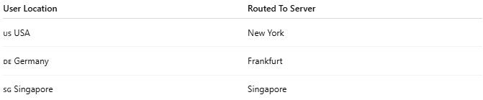
User Location | Routed To Server
🇺🇸 USA | New York
🇩🇪 Germany | Frankfurt
🇸🇬 Singapore | Singapore
✅ Users get the fastest load times, with reduced network lag

⚠️ Limitations
# Source: AI Source: Provided by: [Data Path: Persons Table -> ID Column: 1, Name_En Column: Motasem Essam] -> From: [ChatGPT] on [12/15/2025]
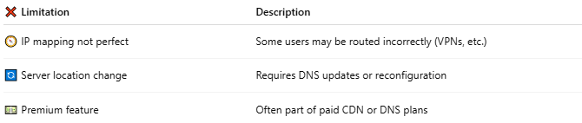

❌ Limitation | Description
🧭 IP mapping not perfect | Some users may be routed incorrectly (VPNs, etc.)
🔄 Server location change | Requires DNS updates or reconfiguration
💵 Premium feature | Often part of paid CDN or DNS plans

🆚 Geo vs Round Robin vs IP Hash
# Source: AI Source: Provided by: [Data Path: Persons Table -> ID Column: 1, Name_En Column: Motasem Essam] -> From: [ChatGPT] on [12/15/2025]
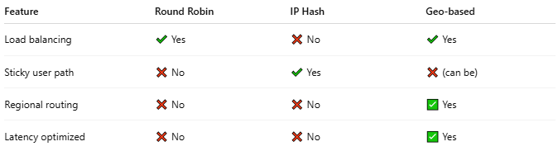

Feature | Round Robin | IP Hash | Geo-based
Load balancing | ✔️ Yes | ❌ No | ✔️ Yes
Sticky user path | ❌ No | ✔️ Yes | ❌ (can be)
Regional routing | ❌ No | ❌ No | ✅ Yes
Latency optimized | ❌ No | ❌ No | ✅ Yes

📌 Summary
# Source: AI Source: Provided by: [Data Path: Persons Table -> ID Column: 1, Name_En Column: Motasem Essam] -> From: [ChatGPT] on [12/15/2025]
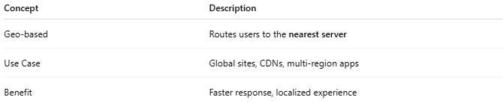

Concept | Description
Geo-based | Routes users to the nearest server
Use Case | Global sites, CDNs, multi-region apps
Benefit | Faster response, localized experience

